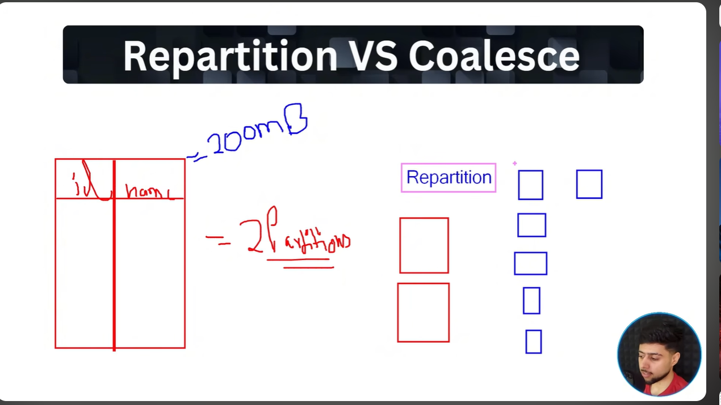
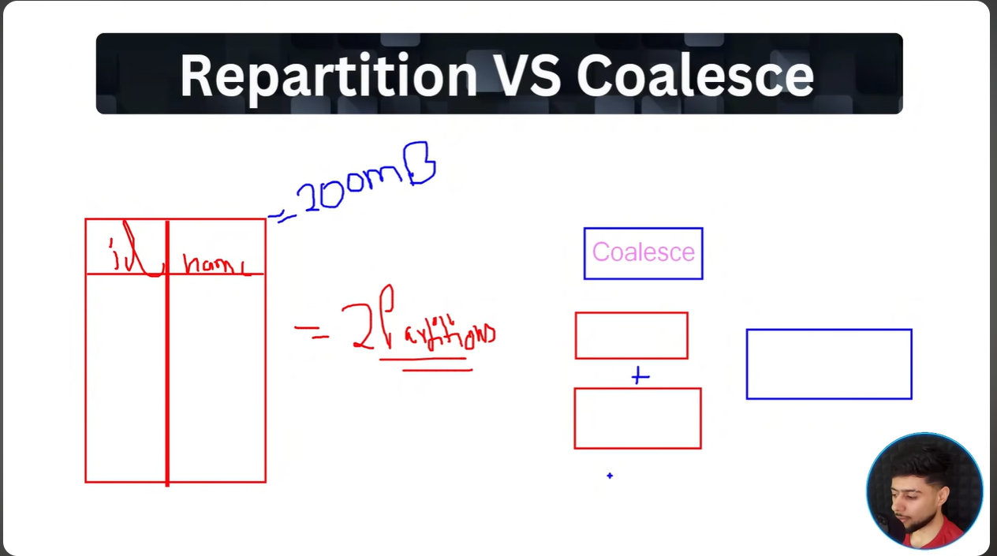
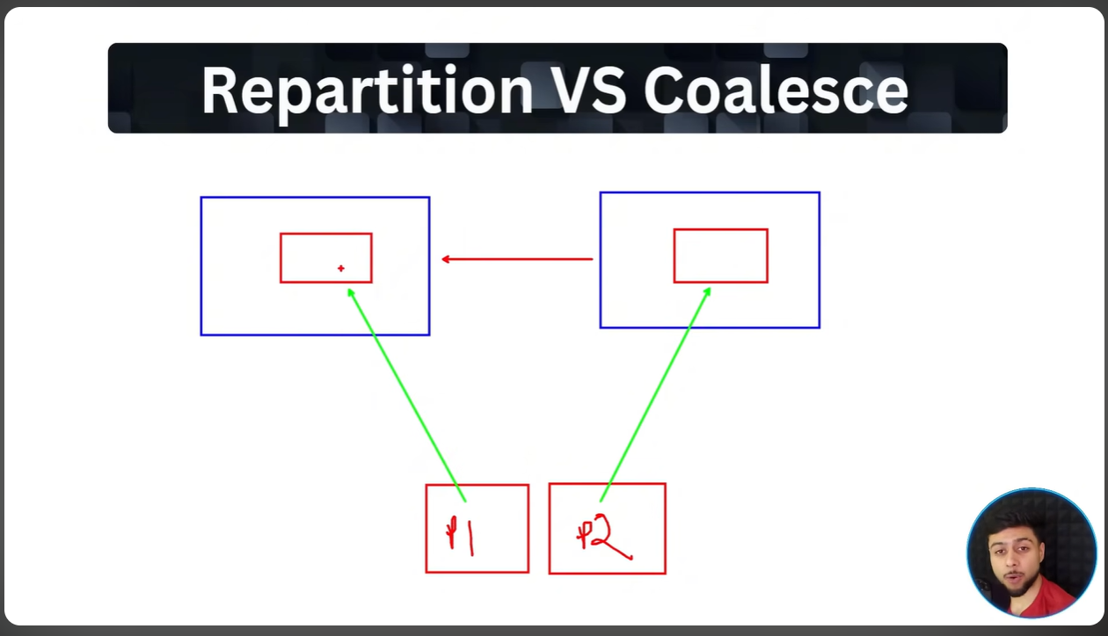

Repartition will increase the no. of partition (shuffling)
Coalesce will merge the partition (in various rare scenarios re-shuffling is required ).

Reference to code : https://dbc-e409b028-0a41.cloud.databricks.com/editor/notebooks/97372252888689?o=7474645623127556#command/4759082041973346

